**Population:** A species having growth is called a population.

**Example:** Human, Tree, animal etc.

**Population Dynamics:** The study of the dynamics of the growth of a population is called population dynamics.

**Model:** Mathematical formulation of a physical problem is called a model.

**Population Model:** Mathematical formulation of the growth of a population is called a population model. Types of population models are as follows:

* Single species → human, cow.
* Two species → cow and grass.
* Three species → man and cow and grass.

**Growth:** If *N* is the number of population at any time *t*, then $dN/dt$ represents the change of population *N* with respect to *t* (time), $≥0$, $t≥0$.

* If $\frac{dN}{dt}>0$, then *N* increases with time *t*.
* If $\frac{dN}{dt}<0$, then *N* decreases with time *t*.
* If $\frac{dN}{dt}=0$, then *N* remains constant with time *t*.

**Line Element:** We consider a differential equation



The differential equation (1) represents the slope of the integral curves of (1). A short segment of the tangent line to the integral curves of (1) is called a line element of (1).

**Question-01:** Explain the method of direction field for the differential equation .

**OR**

Define direction field.

**Answer:** Consider the following first order differential equation



where,  is a real valued function of *x*, *y* and is defined at . The graphs of the explicit solutions of (1) are called the integral curves or solution curves of (1). At each point  at which  is defined, the differential equation (1) defines the slope  of the integral curve of (1) at the point .

Thus we may construct the tangent to an integral curve of (1) at a given point . A short segment of the tangent line through the point  with the slope  is called a line element of (1). If we draw a large number of line elements for a large number of points, then we obtain a configuration called a line element configuration.

The totality of the line element together with the corresponding directions so defined constitute a field called direction field.

**Isocline:**We consider the following differential equation



A curve along which the slope  has a constant value  is called an isocline of the differential equation (1). The isocline lines of (1) are



where,  represents the slopes of the integral curves of (1).

**Question-02:** Explain the method of isocline for the differential equation .

**Answer:** Step-01: We consider the following differential equation



The isoclines of (1) are given by



where,  represents the slopes of the integral curves of (1). We now construct several number of this family for 

Step-02: We consider a particular isocline  of the family (2). At all point on

this isocline, the line elements have the same slope  and hence the same inclination



At a series of points along the isocline we construct the line elements having this inclination .

Step-03: We repeat step-02 for each of isoclines of the family (2) constructed in step-01.

In this way, the line element configuration begins to take shape.

Step-04: Finally, we draw the smooth curves indicated by the line element configuration

obtain in step-03. These smooth curves are the approximate integral curves of (1).

**Problem-01:** Sketch the approximate integral curves of 

**Solution:** We have, 

The isoclines of (1) are given by





where,  is a parameter which represents the slopes of the integral curves of (1).

The equation (2) represents a family of straight lines. We first construct the lines (2) for etc. We then construct a number of line elements having the approximate inclination . Finally we draw several smooth curves. These smooth curves represent the approximate integral curves of (1).

From (2) we find that,

When  ,  then 

When  ,  then 

When  ,  then 

When  ,  then 

When  ,  then 



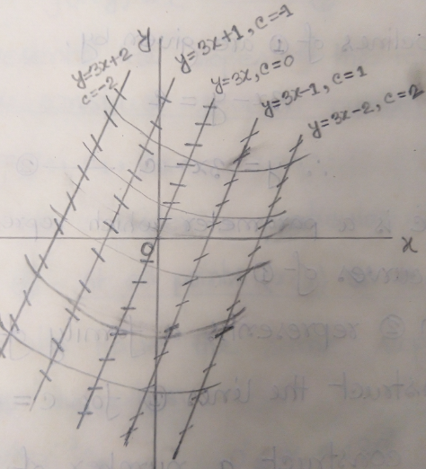

**Problem-02:** Sketch the approximate integral curves of 

**Solution:** We have, 

The isoclines of (1) are given by





where,  is a parameter which represents the slopes of the integral curves of (1).

The equation (2) represents a family of straight lines. We first construct the lines (2) for . We then construct a number of line elements having the approximate inclination . Finally we draw several smooth curves. These smooth curves represent the approximate integral curves of (1).

From (2) we find that,

When  ,  then 

When  ,  then 

When  ,  then 

When  ,  then 

When  ,  then 



When  ,  then 

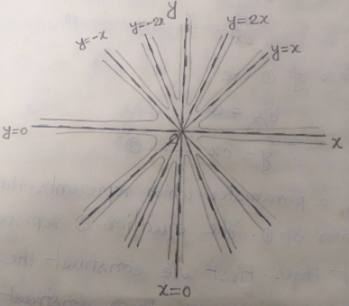

**Problem-03:** Sketch the approximate integral curves of 

**Solution:** We have, 

The isoclines of (1) are given by





where,  is a parameter which represents the slopes of the integral curves of (1).

The equation (2) represents a family of straight lines. We first construct the lines (2) for . We then construct a number of line elements having the approximate inclination . Finally we draw several smooth curves. These smooth curves represent the approximate integral curves of (1).

From (2) we find that,

When  ,  then 

When  ,  then 

When  ,  then 

When  ,  then 

When  ,  then 



When  ,  then 

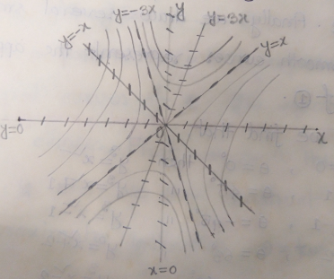

**Problem-04:** Sketch the approximate integral curves of 

**Solution:** We have, 

The isoclines of (1) are given by





where,  is a parameter which represents the slopes of the integral curves of (1).

The equation (2) represents a family of curves. We first construct the lines (2) for etc. We then construct a number of line elements having the approximate inclination . Finally we draw several smooth curves. These smooth curves represent the approximate integral curves of (1).

From (2) we find that,

When  ,  then 

When  ,  then 

When  ,  then 

When  ,  then 

When  ,  then 



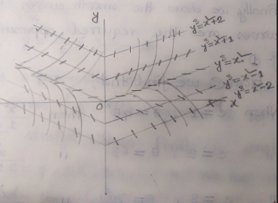

**Problem-05:** Sketch the approximate integral curves of 

**Solution:** We have, 

The isoclines of (1) are given by



where,  is a parameter which represents the slopes of the integral curves of (1).

The equation (2) represents a family of ellipses. We first construct the lines (2) for etc. We then construct a number of line elements having the approximate inclination . Finally we draw several smooth curves. These smooth curves represent the approximate integral curves of (1).

From (2) we find that,

When  ,  then 

When  ,  then 

When  ,  then 

When  ,  then 



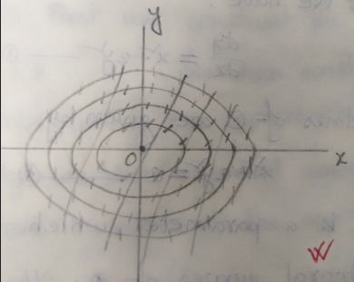

**Problem-06:** Sketch the approximate integral curves of 

**Solution:** We have, 

The isoclines of (1) are given by





where,  is a parameter which represents the slopes of the integral curves of (1).

The equation (2) represents a family of straight lines. We first construct the lines (2) for . We then construct a number of line elements having the approximate inclination . Finally we draw several smooth curves. These smooth curves represent the approximate integral curves of (1).

From (2) we find that,

When  ,  then 

When  ,  then 

When  ,  then 

When  ,  then 

When  ,  then 



When  ,  then 

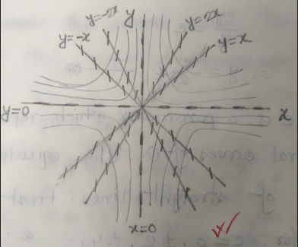

**Problem-07:** Sketch the approximate integral curves of 

**Solution:** We have, 

The isoclines of (1) are given by





where,  is a parameter which represents the slopes of the integral curves of (1).

The equation (2) represents a family of straight lines. We first construct the lines (2) for etc. We then construct a number of line elements having the approximate inclination . Finally we draw several smooth curves. These smooth curves represent the approximate integral curves of (1).

From (2) we find that,

When  ,  then 

When  ,  then 

When  ,  then 

When  ,  then 

When  ,  then 



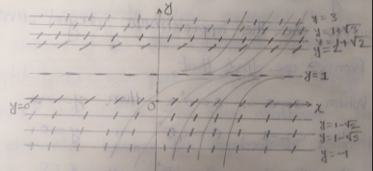

**Problem-08:** Sketch the approximate integral curves of 

**Solution:** We have, 

The isoclines of (1) are given by





where,  is a parameter which represents the slopes of the integral curves of (1).

The equation (2) represents a family of straight lines. We first construct the lines (2) for . We then construct a number of line elements having the approximate inclination . Finally we draw several smooth curves. These smooth curves represent the approximate integral curves of (1).

From (2) we find that,

When  ,  then 

When  ,  then 

When  ,  then 



When  ,  then 

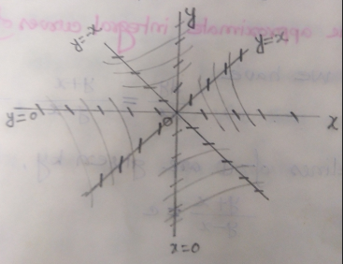

**Problem-09:** Sketch the approximate integral curves of 

**Solution:** We have, 

The isoclines of (1) are given by





where,  is a parameter which represents the slopes of the integral curves of (1).

The equation (2) represents a family of straight lines. We first construct the lines (2) for . We then construct a number of line elements having the approximate inclination . Finally we draw several smooth curves. These smooth curves represent the approximate integral curves of (1).

From (2) we find that,

When  ,  then 

When  ,  then 

When  ,  then 

When  ,  then 

When  ,  then 

When  ,  then 

When  ,  then 



When  ,  then 

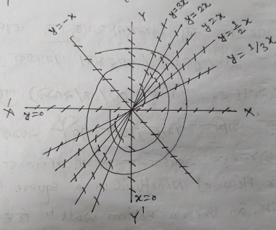

**Problem-10:** Sketch the approximate integral curves of 

**Solution:** We have, 

The isoclines of (1) are given by





where,  is a parameter which represents the slopes of the integral curves of (1).

The equation (2) represents a family of parabolas. We first construct the lines (2) for . We then construct a number of line elements having the approximate inclination . Finally we draw several smooth curves. These smooth curves represent the approximate integral curves of (1).

From (2) we find that,

When  ,  then 

When  ,  then 

When  ,  then 

When  ,  then 

When  ,  then 



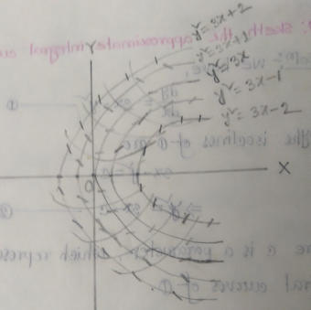

**Critical Point:** We consider the ordinary differential equations of the form





A point  at which  and  is called a critical point.

**Isolated Critical Point:** We consider the ordinary differential equations of the form



and letis a critical point of (1). Nowis called an isolated critical point of (1) if there exist a circle.

**Path:** We consider an autonomous system



and let 

be a solution of (1), where  and  are not both constants. The directed curve describe parametrically by (2) in the phase plane is called a path of (1).

**Phase Portrait:** We consider an autonomous system



and let 

be a solution of (1), where  and are arbitrary constants. The paths of (1) are described parametrically by (2). The diagram of the paths of (1) in the phase plane is called the phase portrait of (1).

**Node:** An isolated critical point of an autonomous system which is appeared and entered by a family of half-line paths, two half-line and a family of S-shaped paths or four half-lines and a family of semi-parabola like paths of the autonomous system as or as is called a node.

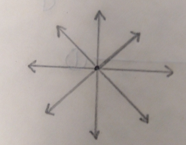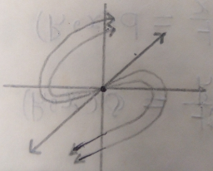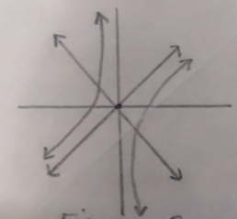

Figure-01 Figure-02 Figure-03

**Saddle point:** An isolated critical point of an autonomous system which is appeared and entered by two half-line paths as , is appeared and entered by another two half-line paths as and is not appeared by the family of hyperbola like paths contained in each region of the four regions between the four half-lines as  or another of the four half-line paths as  or as , but where the hyperbola like paths become or as, but where the hyperbola like paths become asymptotic to one or another of the four half-line paths asor as , is called a saddle point.

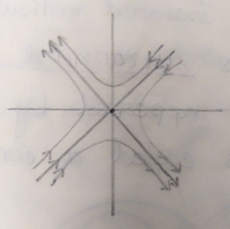

Figure: Saddle point.

**Spiral:** An isolated critical point of an autonomous system which is appeared in a spiral like manner by a family of non-rectilinear paths but is not entered by any paths as or as is called a spiral or focus.

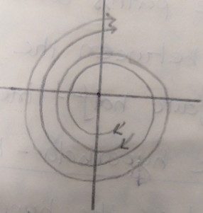 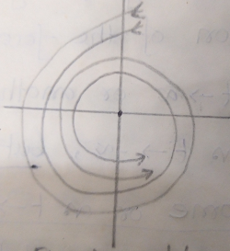

Figure-01: Unstable Spiral. Figure-02: Asymptotic stable Spiral.

**Centre:** An isolated critical point of an autonomous system which is surrounded by a family of closed paths but is not appeared by any path as or as is called a centre.

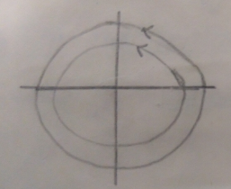 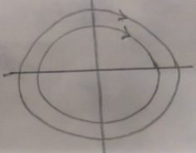

Figure: Centre.

**Stability:** We consider an autonomous system



Let  be a critical point of (1) and let  be a path of (1) defined parametrically by a solution ,  of (1). The critical point  is said to be stable if for each positive number , there exist a positive number  such that every path  which is inside the circle



For some  , remains inside the circle



for all .

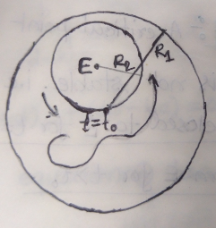

Figure: Stable point.

**Asymptotic Stability:** We consider an autonomous system



Let  be a critical point of (1) and let  be a path of (1) defined parametrically by a solution ,  of (1). The critical point  is said to be asymptotically stable if it is stable and there exist a circle



such that every path which is inside this circle for some  , approaches the critical point  as .

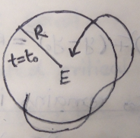

Figure: Asymptotical Stable point.

**Instability** A critical point of an autonomous system is instable if it is not stable i.e.  is unstable if all paths of (1) which are closed to  for  move away from  for .

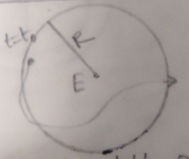

Figure: Unstable point.

**Question-01:** Find the nature and stability of the critical points of a two species linear system.

**Answer:** We consider the linear system



where  are real constants.

The origin is a critical point of (1).

We assume that,



and hence is the only critical point of (1).

Now we seek a solution of (1) of the form

 ; 

where  are constants.

The characteristic equation is







Because of (2), the equation (4) has two non-zero roots.

Let,  and .

The nature and stability of the critical point of (1) depends upon the nature and sign of the roots of  and .

**Case-I:** When  and are real and unequal then the general solution can be written as,



where ,, , ,, are arbitrary constants and .

**Sub case-I(a):** When  and , then the four half lines and the family of semi-parabola like paths approach and enter  as .

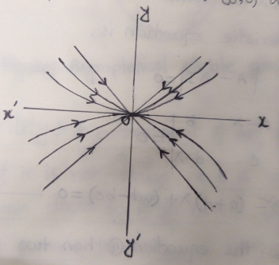

Figure: I(a)

Hence is an asymptotically stable node.

**Sub case-I(b):** When  and , then the four half lines and the family of semi-parabola like paths approach and away as .

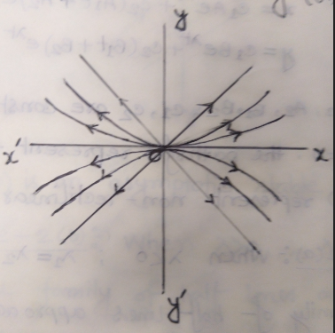

Figure: I(b)

Hence is an unstable node.

**Sub case-I(c):** When  and  or  and then the critical point is unstable saddle.

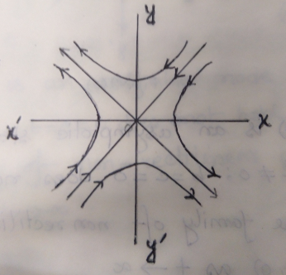 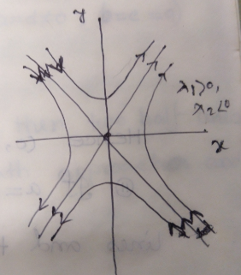

, Figure: I(c) ,

**Case-II:** When  and are real and equal i.e. then the general solution can be written as,



where ,, , ,, are arbitrary constants and .

For  the paths of (6) represent two half paths.

For , (6) represent non-rectilinear paths.

**Sub case-II(a):** When , then

1. the family of half lines approach and enter  as . where .

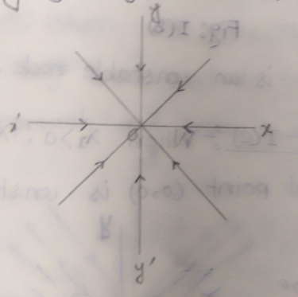

Figure: 2a(1)

Hence is an asymptotically stable node.

1. If  does not hold then two half lines and the family of non-rectilinear paths approach and enter as .

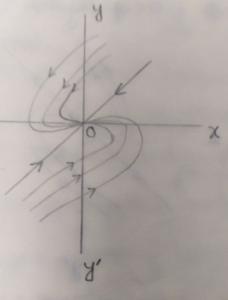

Figure: 2a(2)

Hence is an asymptotically stable node.

**Sub case-II(b):** When , then

1. the family of half lines approach and away  as .

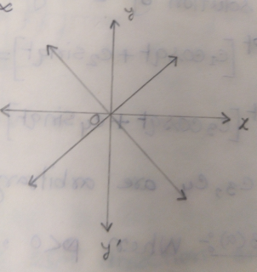

Figure: 2b(1)

Hence is an unstable node. where .

1. If  does not hold then two half lines and the family of non-rectilinear paths approach and away as .

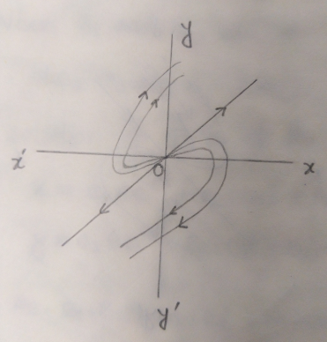

Figure: 2b(2)

Hence is an unstable node.

**Case-III:** When  and are complex. Let and then the general solution can be written as,



where , ,, are arbitrary constants.

**Sub case-III(a):** When  and , then  is asymptotically stable spiral.

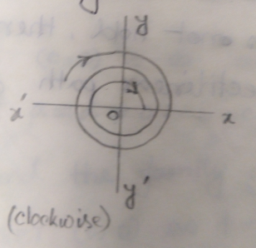 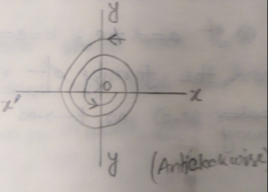

Figure: 3(a)

**Sub case-III(b):** When  and , then is unstable spiral.

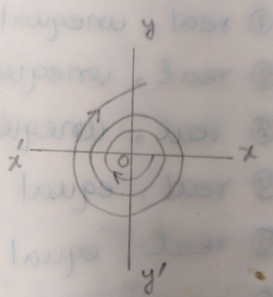 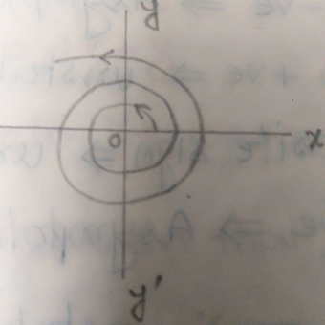  
 Figure: 3(b)

**Sub case-III(c):** When  and  i.e. purely imaginary then  is a stable centre.

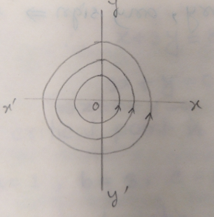 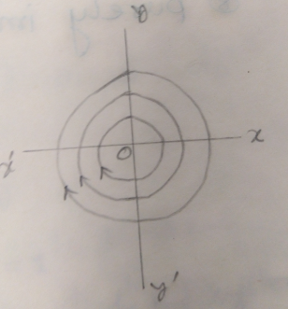

Figure: 3(c)

NOTE: (1) For stable the direction will be toward the critical point.

1. For unstable the direction will be outward the critical point.

NOTE: If the roots are:

1. Real, unequal and both unstable node.
2. Real, unequal and both asymptotic stable node.
3. Real, unequal and opposite signunstable saddle.
4. Real, equal andasymptotic stable node.
5. Real, equal and unstable node.
6. Imaginary, Real part asymptotic stable spiral.
7. Imaginary, Real part  unstable spiral.
8. Purely imaginary, any sign stable centre.

**Problem-11:** Find the nature and stability of the critical points of



and sketch its phase portrait.

**Solution:** Given that



For critical point 

From (1), we have



Solving (2), we get



Therefore, the critical point is .

Here 

Now the characteristic equation of the system is







The characteristic roots are real, unequal and of opposite sign. Hence the critical point is an unstable saddle.

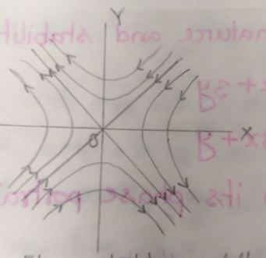

Figure: Unstable saddle.

**2nd part:**

 

The isoclines of (3) are given by

 

where,  is a parameter which represents the slopes of the integral curves of (3).

The equation (4) represents a family of straight lines. We first construct the lines (4) for etc. We then construct a number of line elements having the approximate inclination . Finally we draw several smooth curves. These smooth curves represent the approximate integral curves of (3).

From (4) we find that,

When  ,  then 

When  ,  then 

When  ,  then 

When  ,  then 

When  ,  then 



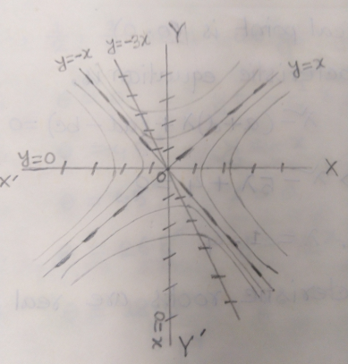

which is required phase portrait.

**Problem-12:** Find the nature and stability of the critical points of



and sketch its phase portrait.

**Solution:** Given that



For critical point 

From (1), we have



Solving (2), we get



Therefore, the critical point is .

Here 

Now the characteristic equation of the system is







The characteristic roots are real, unequal and both positive. Hence the critical point is an unstable node.

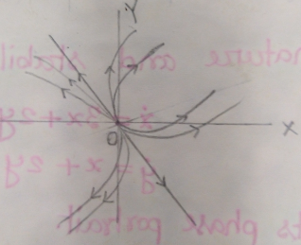

**2nd part:**





The isoclines of (3) are given by





where,  is a parameter which represents the slopes of the integral curves of (3).

The equation (4) represents a family of straight lines. We first construct the lines (4) for etc. We then construct a number of line elements having the approximate inclination . Finally we draw several smooth curves. These smooth curves represent the approximate integral curves of (3).

From (4) we find that,

When  ,  then 

When  ,  then 

When  ,  then 

When  ,  then 

When  ,  then 



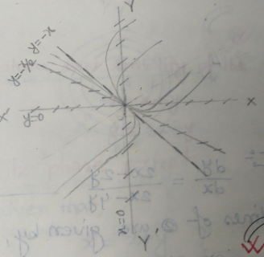

which is required phase portrait.

**Problem-13:** Find the nature and stability of the critical points of



and sketch its phase portrait.

**Solution:** Given that



For critical point 

From (1), we have



Solving (2), we get



Therefore, the critical point is .

Here 

Now the characteristic equation of the system is







The characteristic roots are purely imaginary. Hence the critical point is a stable centre.

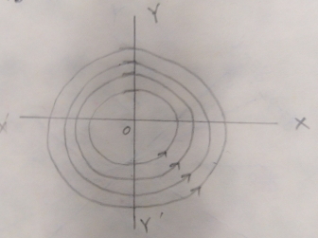

**2nd part:**





The isoclines of (3) are given by





where,  is a parameter which represents the slopes of the integral curves of (3).

The equation (4) represents a family of straight lines. We first construct the lines (4) for etc. We then construct a number of line elements having the approximate inclination . Finally we draw several smooth curves. These smooth curves represent the approximate integral curves of (3).

From (4) we find that,

When  ,  then 

When  ,  then 

When  ,  then 

When  ,  then 

When  ,  then 



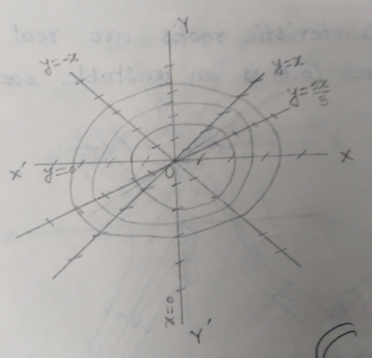

which is required phase portrait.

**Problem-14:** Find the nature and stability of the critical points of



and sketch its phase portrait.

**Solution:** Given that



For critical point 

From (1), we have



Solving (2), we get



Therefore, the critical point is .

Here 

Now the characteristic equation of the system is







The characteristic roots are real, equal and opposite sign. Hence the critical point is an unstable saddle.

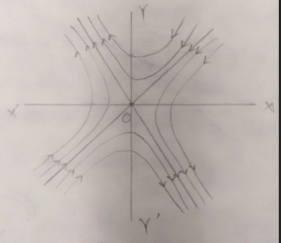

**2nd part:**





The isoclines of (3) are given by





where,  is a parameter which represents the slopes of the integral curves of (3).

The equation (4) represents a family of straight lines. We first construct the lines (4) for etc. We then construct a number of line elements having the approximate inclination .

From (4) we find that,

When  ,  then 

When  ,  then 

When  ,  then 

When  , then 

When  ,  then 



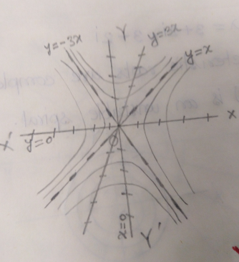

which is required phase portrait.

**Problem-15:** Find the nature and stability of the critical points of



and sketch its phase portrait.

**Solution:** Given that



For critical point 

From (1), we have



Solving (2), we get



Therefore, the critical point is .

Here 

Now the characteristic equation of the system is













The characteristic roots are complex and real part . Hence the critical point is an unstable spiral.

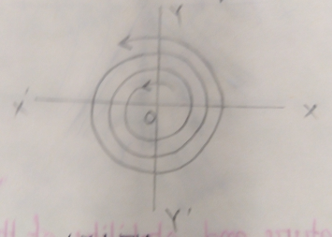

**2nd part:**





The isoclines of (3) are given by





where,  is a parameter which represents the slopes of the integral curves of (3).

The equation (4) represents a family of straight lines. We first construct the lines (4) for etc. We then construct a number of line elements having the approximate inclination .

From (4) we find that,

When  ,  then 

When  ,  then 

When  ,  then 

When  ,  then 

When  ,  then 

When  ,  then 

When  ,  then 

When  ,  then 

When  , then 



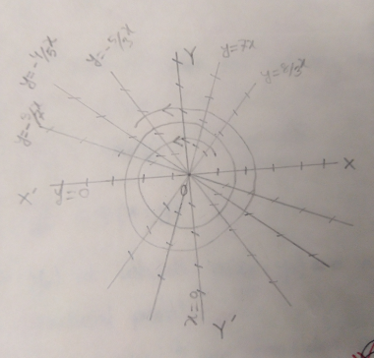

which is required phase portrait.

**Liapunov Function:** Suppose that the autonomous system



has an isolated critical point at and have continuous first order partial derivatives for all . If there exists a function  such that

1.  is differentiable function for all 
2.  is positive definite for all , and
3.  is either  definite or  semi definite for all .

Then  is called Liapunov function for the system (1).

**Liapunov function for 3-dimensions:** Suppose that the autonomous system



has an isolated critical point at and have continuous first order partial derivatives for all . If there exists a function  such that

1.  is differentiable function for all 
2.  is positive definite for all , and
3.  is either  definite or  semi definite for all .

Then  is called Liapunov function for the system (1).

**Question:** State the three theorems of Liapunov function.

**Answer:** The statements of the three theorems of Liapunov function are given below:

(1) If for an autonomous system there exists a differentiable function  such that  is  definite and  is  definite

i.e. 

then the critical point  of the system is asymptotically stable.

(2) If for an autonomous system there exists a differentiable function  such that  is  definite and  is semi definite

i.e. 

then the critical point  of the system is stable.

(3) If for an autonomous system there exists a differentiable function  such that  and  are definite

i.e. 

then the critical point  of the system is unstable.

**Globally asymptotic stable solution:** Let  be a solution of an autonomous system then  is called globally asymptotic stable solution of this system if is differentiable,  is  definite and  is  definite.

**NOTE:** A function  is

1.  definite if .
2.  semi definite if .
3.  definite if .
4.  semi definite if .

**Problem-16:** Show that is a Liapunov function for the system

.

What can you say about the stability of .

**Solution:** We have



The given function is











Now we observed that,

1.  is a differentiable function
2.  is  definite and
3.  is  definite.

Hence  is a Liapunov function for the system (1) and the critical point  is asymptotically stable. **(Showed)**

**Problem-17:** Verify whether is a globally asymptotically stable solution of the system

.

**Solution:** We have



The given function is













Now we observed that,

1.  is a differentiable function
2.  is  definite and
3.  is  definite.

Hence  is a globally asymptotically stable solution of this system. **(Verified)**

**Problem-18:** Construct a Liapunov function of the form  where  and are constants and use the function to determine whether the critical point  is asymptotically stable or at least stable of the system

.

**Solution:** We have



Let,













Now we observed that,

1.  is a differentiable function
2.  is  definite and
3.  is  definite.

Hence  is a Liapunov function for the system (1) and the critical point is asymptotically stable.

**Problem-19:** For what values of  , is a Liapunov function for the system

.

**Solution:** We have



The given function is











Now we observed that,

1.  is a differentiable function
2.  is  definite and
3. If and are sufficiently small, then the sign of is determined by  since

. Thus if , then  is  semi definite.

Hence  is a Liapunov function for the system (1)

Again, if then  is  definite.

Therefore the critical point  is asymptotically stable when .

**Problem-20:** Verify whether is a stable solution for the system



at the origin.

**Solution:** We have



The given function is











Now we observed that,

1.  is a differentiable function
2.  is  definite and
3.  is  semi definite

Hence  is a Liapunov function of (1) and is stable at the origin.

**Problem-21:** Construct a Liapunov function of the form  where  and are constants and use the function to determine whether the critical point  is asymptotically stable or at least stable of the system

.

**Solution:** We have



Let,













Now we observed that,

1.  is a differentiable function
2.  is  definite and
3.  is  definite.

Hence  is a Liapunov function for the system (1) and the critical point  is asymptotically stable.

**Problem-22:** Examine the stability of the trivial solution of



By taking a suitable Liapunov function.

**Solution:** We have



Let,











Now we observed that,

1.  is a differentiable function
2.  is  definite and
3.  is  definite.

Hence  is a Liapunov function for the system (1) and the critical point  is asymptotically stable.

**Problem-23:** Examine the stability of the trivial solution of



By taking a suitable Liapunov function.

**Solution:** We have



Let,









Now we observed that,

1.  is a differentiable function
2.  is  definite and
3.  is  definite.

Hence  is a Liapunov function for the system (1) and the critical point  is asymptotically stable.